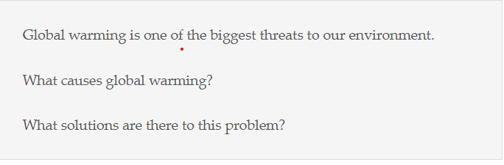

“You reap what you sow” is a proverb that goes back hundreds of years and is significant even to this day. Today, most of us are concerned about global warming as it proving to be detrimental to the ecosystem. This essay discusses on what leads to green house effect and suggests few ways to counter act this issue. [57]

To begin with, human beings have caused enough damage to the planet with their actions. In other words, CO2 from vehicular traffic and industries is one of the key factors leading to ozone layer depletion and allowing ultra-violet radiation to enter into the earth’s amosphere. In addition, some natural phenomena like volcanic eruptions or geo thermal springs could also increase amospheric temerature which further renders degradation of ozone shield. For example,today green house gases are reponsible for the rise in temparatures dratiscally and melting the polar ice caps, resulting increase in the sea levels. In this way, mankind is mostly responsible for the changes in weather conditions globally. [108]

One of the panaceas to all such problems is to go-green in all aspects in our daily life. Like, moving away from using vehicles which run on fossil fuels to those which uses green fuels like solar energy or bio gas. Again, governments could chalk out strict policies for pollution control and the public should follow those regulations religiously. Further, stop cutting trees on large scale and afforestation could maintain the balance in climate. Bhutan is an epitome for conserving the environment and being only carbon negative nation in the world. Thus, citizens and authorities have a shared responsibilty in tackling the environmental issues. [106]

In conclusion, although development in science has benefitted us in many ways, the downside of it affecting the environment should not be ignored. Therefore, time has come to think about the future generation along with the wise use of the resources to avoid or mitigate the harmful effects of ozone degradation.[50]

Total : 316

The adage “Your only limit is you” is significant even to this day. Everybody in this world wants to be self-reliant and independent. In the new era, a lot of individuals opt to become entrepreneurs instead of working for others. This essay discusses what triggers someone to start their own business and also examines the negative consequences of this decision. [63]

To begin with, there could be varied reasons for becoming self-employed. First of all, people are getting enough financial support from the banks and the government to start their own establishments with affordable repayment packages. In addition, youngters are getting the required education through B schools and online courses. For instance, Elon Musk, the CEO of Spacex Company started with a small office and made a maiden success because of his great vision, self-determination and monetary help from the American government. Likewise, there are so many successful stories which encourage the new generation to pursue their dreams instead of seeking employment. [96]

Although such initiatives could be fruitful, the downside of such an venture could be disastrous when enthusiastic bosses lack the vision to gauge before starting their own firms, leading to huge losses and failures. Apart from this, new commers could face a stiff competition from old timers, which could lead them to either discontinue their new business or wind up in the red. The classic example that I can recall is my uncle who impulsively started his own IT company and ended up in insolvency. Thus, many businesses fizzle out due to hasty decisions and losses could force them to abandon their dream projects. [104]

In conclusion, although some people could become successful businessmen, the story may not be true for everyone since he or she might lack the vision, R and D or the required capital. Therefore, ending up as an employee could be a better choice than burning one’s fingers by experimenting being an employer. [52]

Total : 323